PROJECT PLANNING PHASE
Auto Ticket Classification using Flow Designer

1. Project Planning Overview
The project planning phase defines how the Auto Ticket Classification using Flow Designer system will be developed, tested, and completed in ServiceNow. The plan identifies the project scope, required resources, major tasks, schedule, risks, testing activities, and expected deliverables. The main goal is to organize the work before configuration begins.

2. Project Scope
- Create an automated workflow for newly created support tickets.
- Use Flow Designer to read ticket details and apply classification rules.
- Update the ticket category based on the identified type.
- Route the classified ticket to the appropriate assignment group.
- Test the flow using different ticket descriptions and conditions.
- Document the final workflow and configuration.

3. Work Breakdown / Major Tasks
Task | Main Activity | Output
1. Requirement Analysis | Identify ticket fields, categories, rules and assignment groups. | Requirement list
2. Workflow Planning | Design trigger, conditions, actions and routing sequence. | Flow plan
3. Configuration | Create and configure the Flow Designer workflow. | Working flow
4. Testing | Check multiple ticket types, field updates and assignment. | Test results
5. Deployment & Documentation | Finalize the flow and prepare project documentation. | Completed project

4. Resources Required
- ServiceNow developer or training instance for configuration and testing.
- Flow Designer for workflow creation and automation.
- Ticket/Incident table and required ticket fields.
- Classification rules such as hardware, software, network, or access conditions.
- Web browser and project documentation tools.

5. Project Planning Flowchart
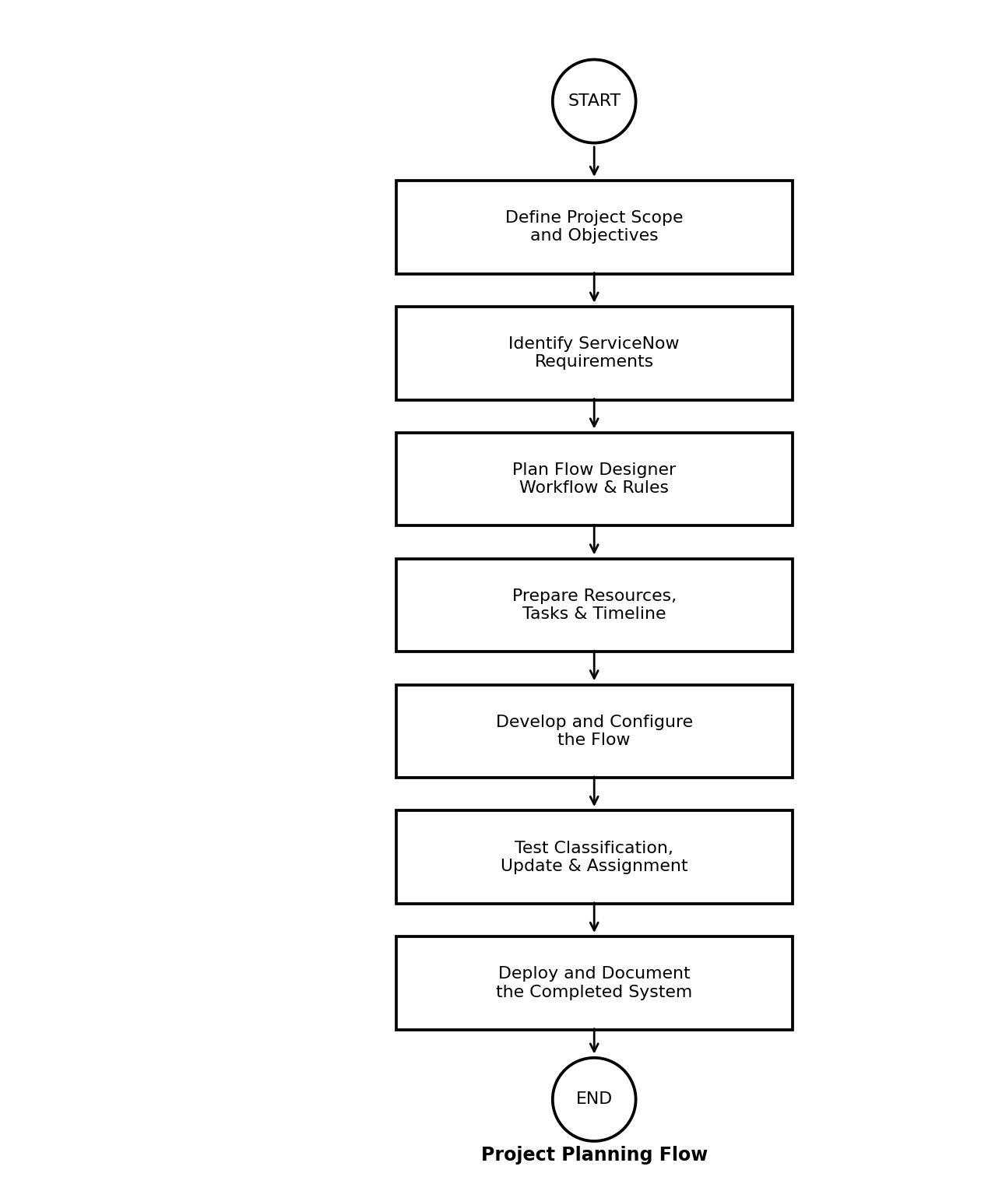

6. Schedule and Milestones
Phase | Planned Work | Milestone
Week 1 | Requirement analysis and scope definition | Requirements finalized
Week 2 | Flow and classification rule planning | Workflow design completed
Week 3 | ServiceNow Flow Designer configuration | Initial flow ready
Week 4 | Testing and correction of issues | Test cases completed
Week 5 | Final deployment and documentation | Project completed

7. Risk and Mitigation Plan

Possible Risk | Effect | Planned Mitigation
Incorrect classification rule | Ticket may receive wrong category. | Test rules with different sample descriptions.
Missing ticket information | Flow may not classify correctly. | Add conditions for required fields and default handling.
Flow configuration error | Workflow may stop or update incorrectly. | Test each action and condition before final deployment.
No matching rule | Ticket may remain unclassified. | Use a default category or manual-review path.

8. Testing and Delivery Plan
Testing will verify that the flow starts correctly, reads the required fields, identifies the expected category, updates the ticket, and assigns it to the correct support group. Both matching and non-matching ticket descriptions will be tested. After successful testing, the final workflow, screenshots, test results, and project documentation will be prepared as deliverables.

9. Expected Deliverables
- Configured ServiceNow Flow Designer workflow.
- Ticket classification conditions and routing rules.
- Test cases and test results.
- Project design and planning documentation.
- Final screenshots of the implemented workflow and ticket results.

10. Conclusion
The project planning phase provides a clear sequence for developing the Auto Ticket Classification system. By defining requirements, tasks, resources, schedule, risks, testing, and deliverables in advance, the project can be implemented in an organized manner using ServiceNow Flow Designer.

